WOLLONGONG I CITY OF INNOVATION

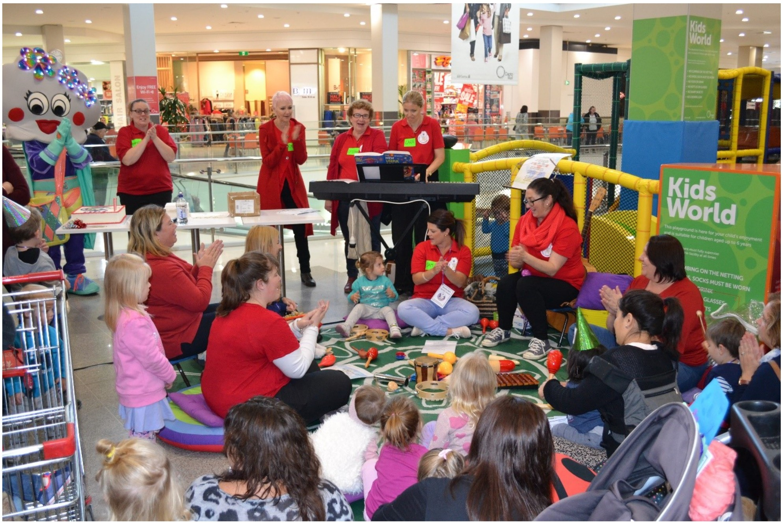

Bright Sparks Birthday
A Paint the GONG REaD Event

wollongong.nsw.gov.au

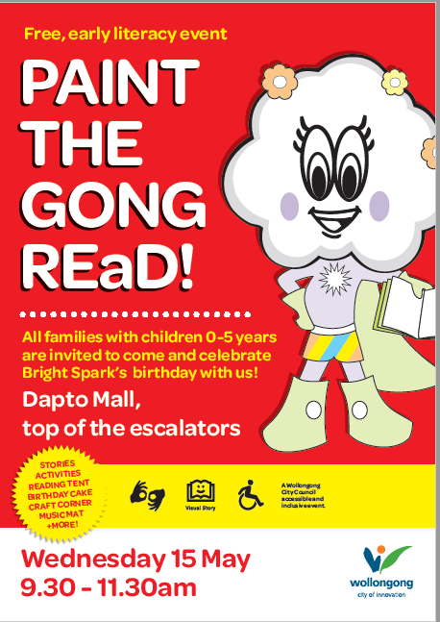
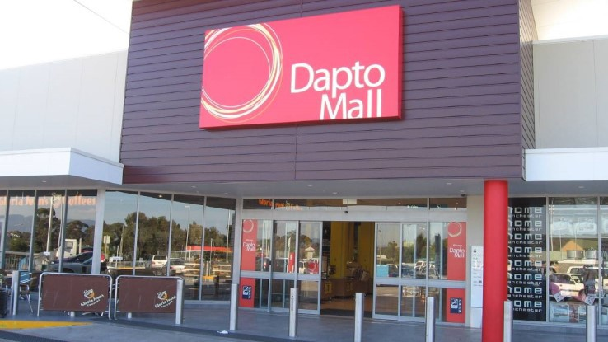
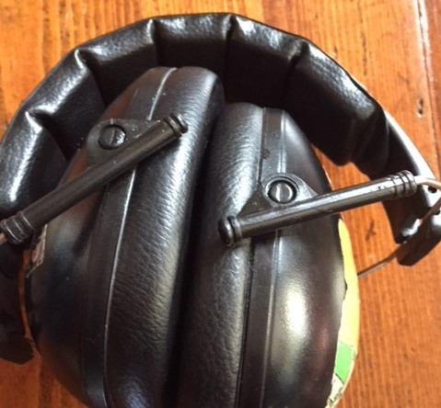

I am going to Bright Sparks Birthday on Wednesday 15 May

The party will be at the top of the escalators at Dapto Mall

There will be lots of people
And it will be noisy. I can bring anything to feel calm and have a nice time. This might include earmuffs or fidgets.
There will be things to help me feel calm there as well.

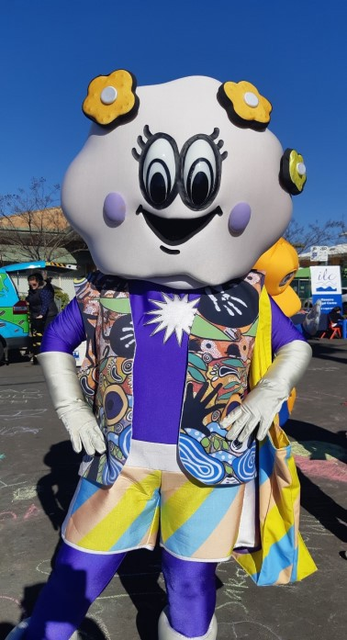
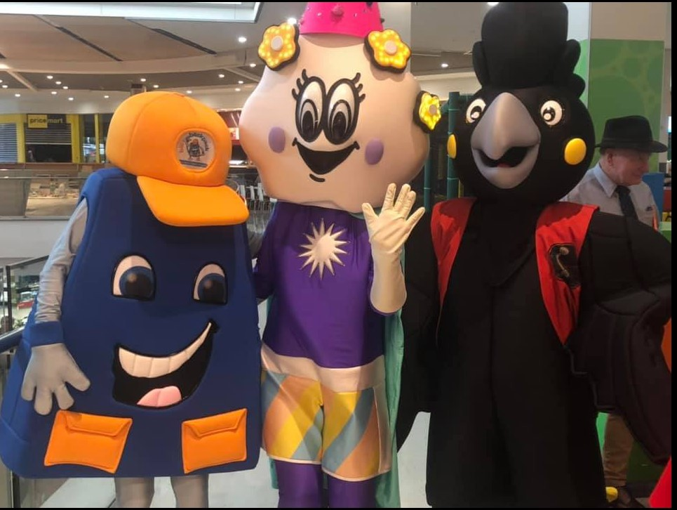
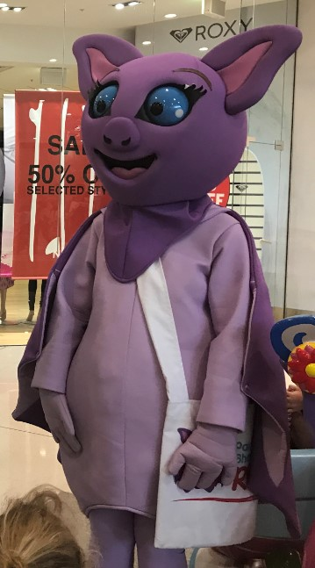
Bright Spark will be there too. I can say hello and give her a high five if I want to.

Some of Bright Sparks friends Agy & Billy Back Pack will be there to say happy Birthday.

Bangu will also be there to say happy Birthday to Bright Spark

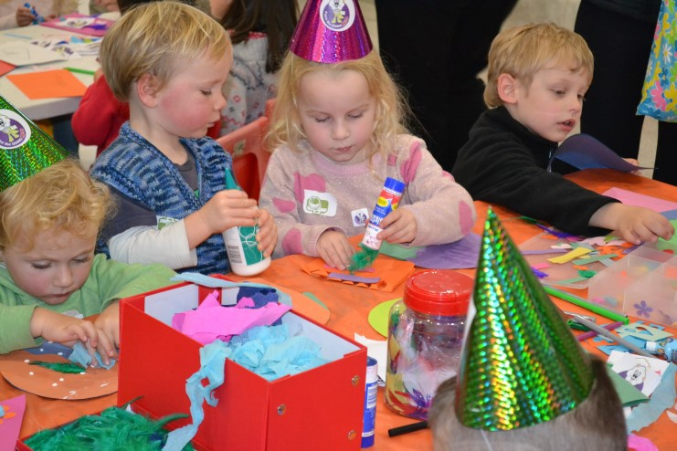
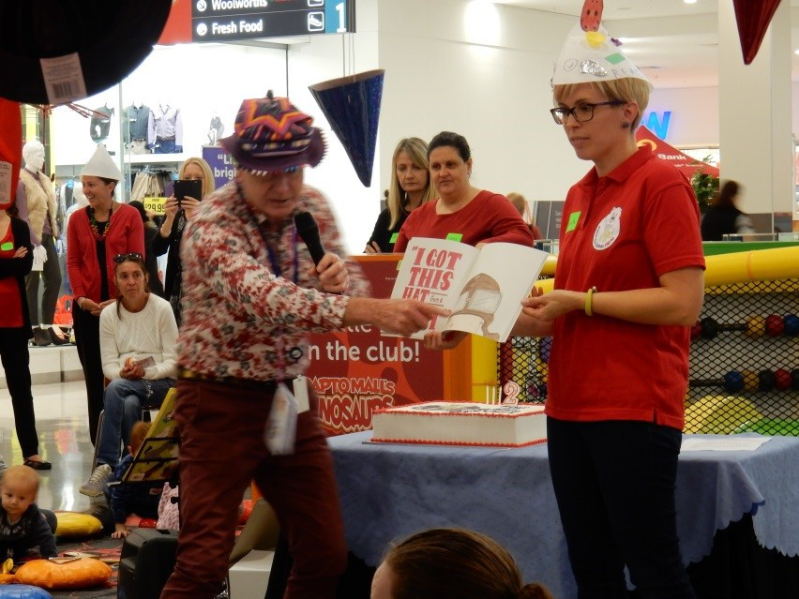
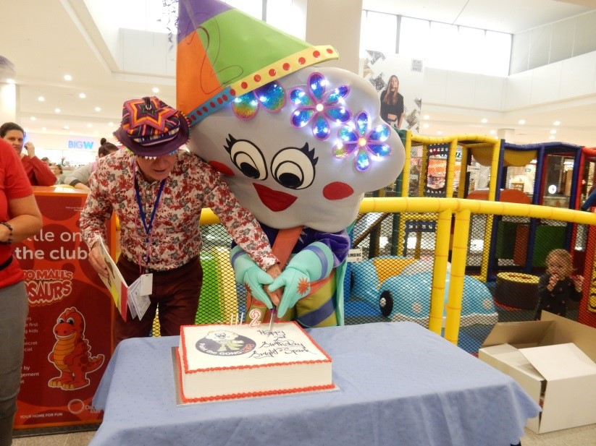

There will be lots of fun things to do at Bright Sparks Birthday.

The Lord Mayor or his friend will read a book to us

We will cut the cake for
Bright Spark’s Birthday

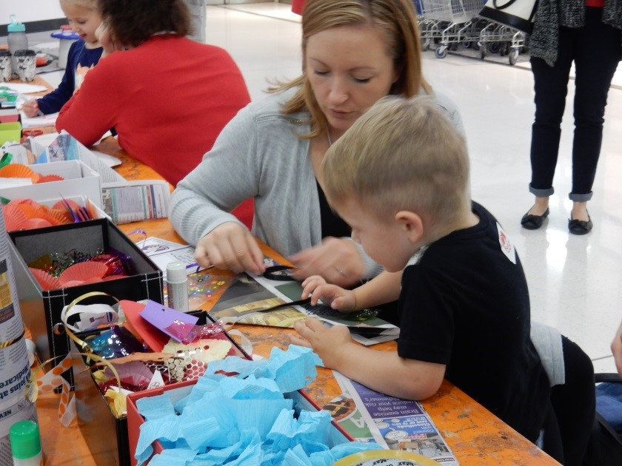
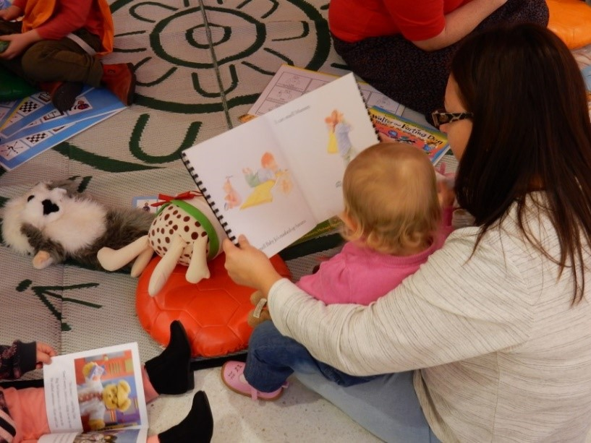
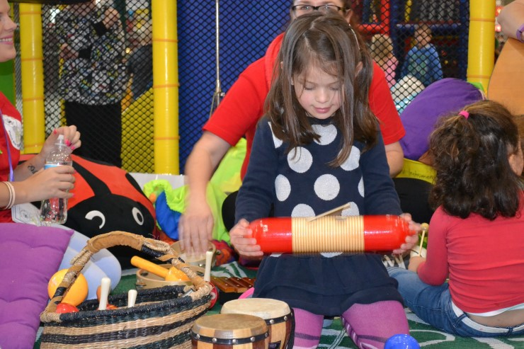

I can do craft

I can make music

I can read books

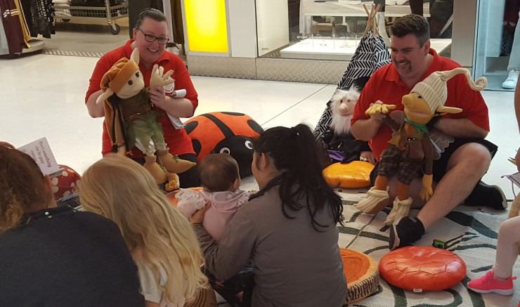
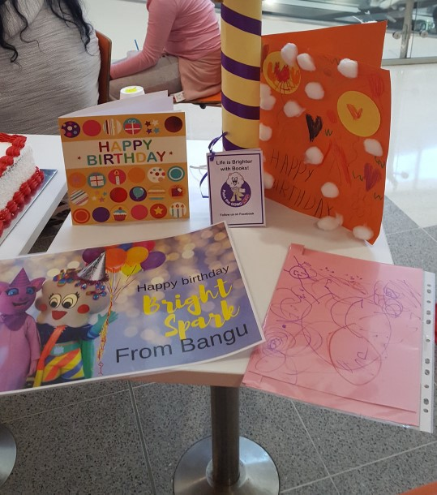

I can listen to a fun story

I can make a Birthday card for Bright Spark at home and give it to her or one of the people helping on the day.

Then it’s time to go home

Thank you for helping us celebrate Bright Spark’s Birthday!

FINISHED

