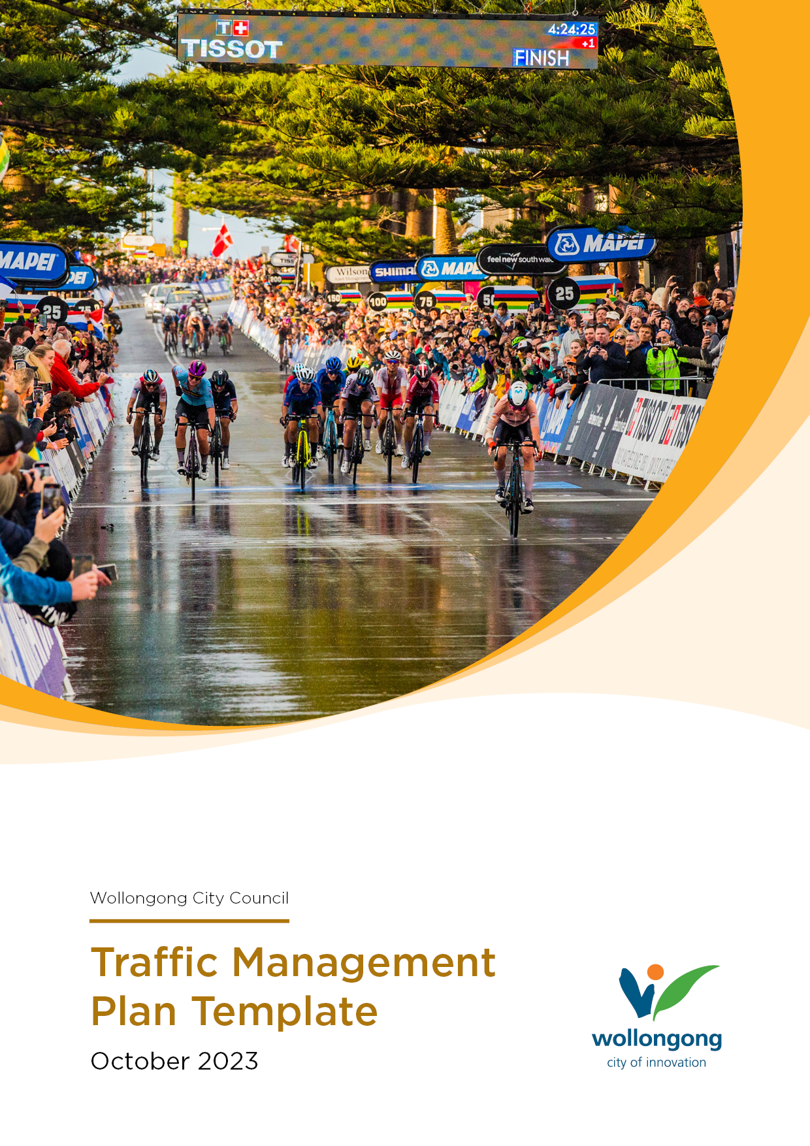

<INSERT EVENT NAME HERE>

SIMPLIFIED EVENT TRAFFIC MANAGEMENT PLAN
for
SMALL TO MEDIUM EVENTS

This is a sample of a simple transport management plan that provides basic information for a small to medium sized event. A more comprehensive traffic management plan may be required depending on the type, size, and location of your event. Please contact the Events Team to confirm what is required for your event.

This Traffic Management Plan forms part of your Event Management Plan
A copy of the Event Management Plan should be retained by the
event organiser for use on the day of the event.

This template is not limited to the information contained and not all sections will be applicable to your event. Please provide any additional information that may assist with the management and planning of your event.

- Essential Information
  - Purpose of a Traffic Management Plan (TMP)
The purpose of a TMP is to maintain an adequate level of use for all road users (including cyclists and pedestrians) and adequately provide for the safety of workers, road users and attendees.
1.2 When is a Traffic Management Plan Required
A TMP is required for any work or event that causes or has the potential to cause disruption to roads and traffic for road users and the general public.
1.3 Traffic Committee
Where an event is likely to affect traffic conditions or require a temporary road closure on any Council roads, or State Government roads, organisers are required to seek approval from Council and Traffic Committee.
Traffic management plans must be submitted for consideration by Council's Traffic Committee, and recommendation to Council. This process has a minimum 8-week turnaround, so please make sure you factor this time in. You can read more about the Traffic Committee and important submission dates on Council’s Traffic Committee page.
1.3 Event Plan
Council requires all event organisers to complete an Event Management Plan. Your event plan provides essential information about your event and documents all aspects of your event including Risk Assessment, Public Liability Insurance and Notification Plan.
Your Traffic Management Plan forms part of your Event Plan and must be submitted simultaneously. You can use the Event Management Plan Template which is available on Council’s website.

Have you prepared an Event Plan? | ☐ Yes ☐ No
Is your Risk Assessment attached to your Event Plan? | ☐ Yes ☐ No
Are your Public Liability Insurance details included in your Event Plan? | ☐ Yes ☐ No
Is your Notification Plan included in your Event Plan? | ☐ Yes ☐ No
Is your Site Map attached to your Event Plan? | ☐ Yes ☐ No
1.4 Stakeholder Consultation
If your event requires a road closure, it is mandatory to notify and consult with your local NSW Police, emergency services and affected Public Transport Operators.
Provide details of stakeholder consultation.
NSW Police | ☐ Yes ☐ No
Local Station:
Date Contacted:
Contact:
Fire Brigades | ☐ Yes ☐ No
Local Station:
Date Contacted:
Contact:
Ambulance | ☐ Yes ☐ No
Local Station:
Date Contacted:
Contact:
Public Transport Operators  Location of Bus routes can be found on Intramaps | ☐ Yes ☐ No
Company Name:
Date Contacted:
Contact:

- Traffic and Transport Environment
2.1 Impact on Traffic and Transport Environment
Describe the impact on Traffic and Transport arrangements bordering your event site.
Roads and Streets | Describe impact on surrounding roads and alternate arrangements proposed
Traffic Lights | Describe impact on nearby traffic lights and alternate arrangements proposed
Existing Speed Arrangements | Provide details of existing speed limits and alternate arrangements proposed
Street Parking | Describe impact on street parking and alternate arrangements proposed
Pedestrian Crossing | Describe impact on nearby pedestrian crossings and alternate arrangements proposed
Footpaths | Describe impact on nearby footpaths and alternate arrangements proposed
Cycle Paths | Describe impact on nearby cycle paths and alternate arrangements proposed
Bus Stops | Describe impact on nearby bus stops and alternate arrangements proposed
Bus Routes | Describe impact on bus routes operating on nearby roads and alternate arrangements proposed
2.2 Road Closures
Does your event require a road closure?
Road Closure required | ☐ Yes ☐ No
Provide details of roads to be closed during the event:
Location of Closure | Time of Closure
e.g., Brown Street between Black Street and Main Street (include name of road closed and names of intersection roads where closures will occur | e.g., 8.00am to 4.00pm
2.3 Traffic Guidance Scheme (TGS)
A Traffic Guidance Scheme (TGS) is a diagram that illustrates the alternate traffic arrangements, position of traffic controllers/marshals and traffic signage and devices used to manage traffic at your event.
Council requires that TGS’s are prepared and implemented by a qualified person or Traffic Management company authorised by TfNSW.
Traffic Guidance Scheme attached | ☐ Yes ☐ No
Have you engaged a Traffic Management company implement the TGS | ☐ Yes ☐ No
Company Details | Name:  Address:  Contact:
Is the Traffic Management Company providing Controllers or Marshals? | ☐ Yes ☐ No | How Many:
2.4 Parking
Provide details about arrangements you have made for Parking.
Every effort will be made to encourage event attendees to use designated parking areas and to ensure the safety of vehicle and pedestrian traffic during the event.
Event Attendees | e.g., designated parking areas and how you will ensure the safety of vehicle and pedestrian traffic during the event.
Event Staff and Volunteers
Contractors and Suppliers
2.5 Access
Provide details about how you will ensure access to impacted residents, business, and emergency services.
Affected Residents | .  e.g., detours, business/resident-only access provisions, entry under escort etc.
Affected Businesses
Emergency Services
Pick Up and Drop Off Zones for Attendees

2.6 Check List
☐ Check Traffic Committee timeframes to ensure your submission complies.
☐ Event Plan prepared (including Risk Assessment, Site Plan, Public Liability information and Notification Plan)
☐ Traffic Management Plan prepared.
☐ Engage Traffic Management Company to prepare and implement the TGS.
☐ Submit completed documents to Events Team

