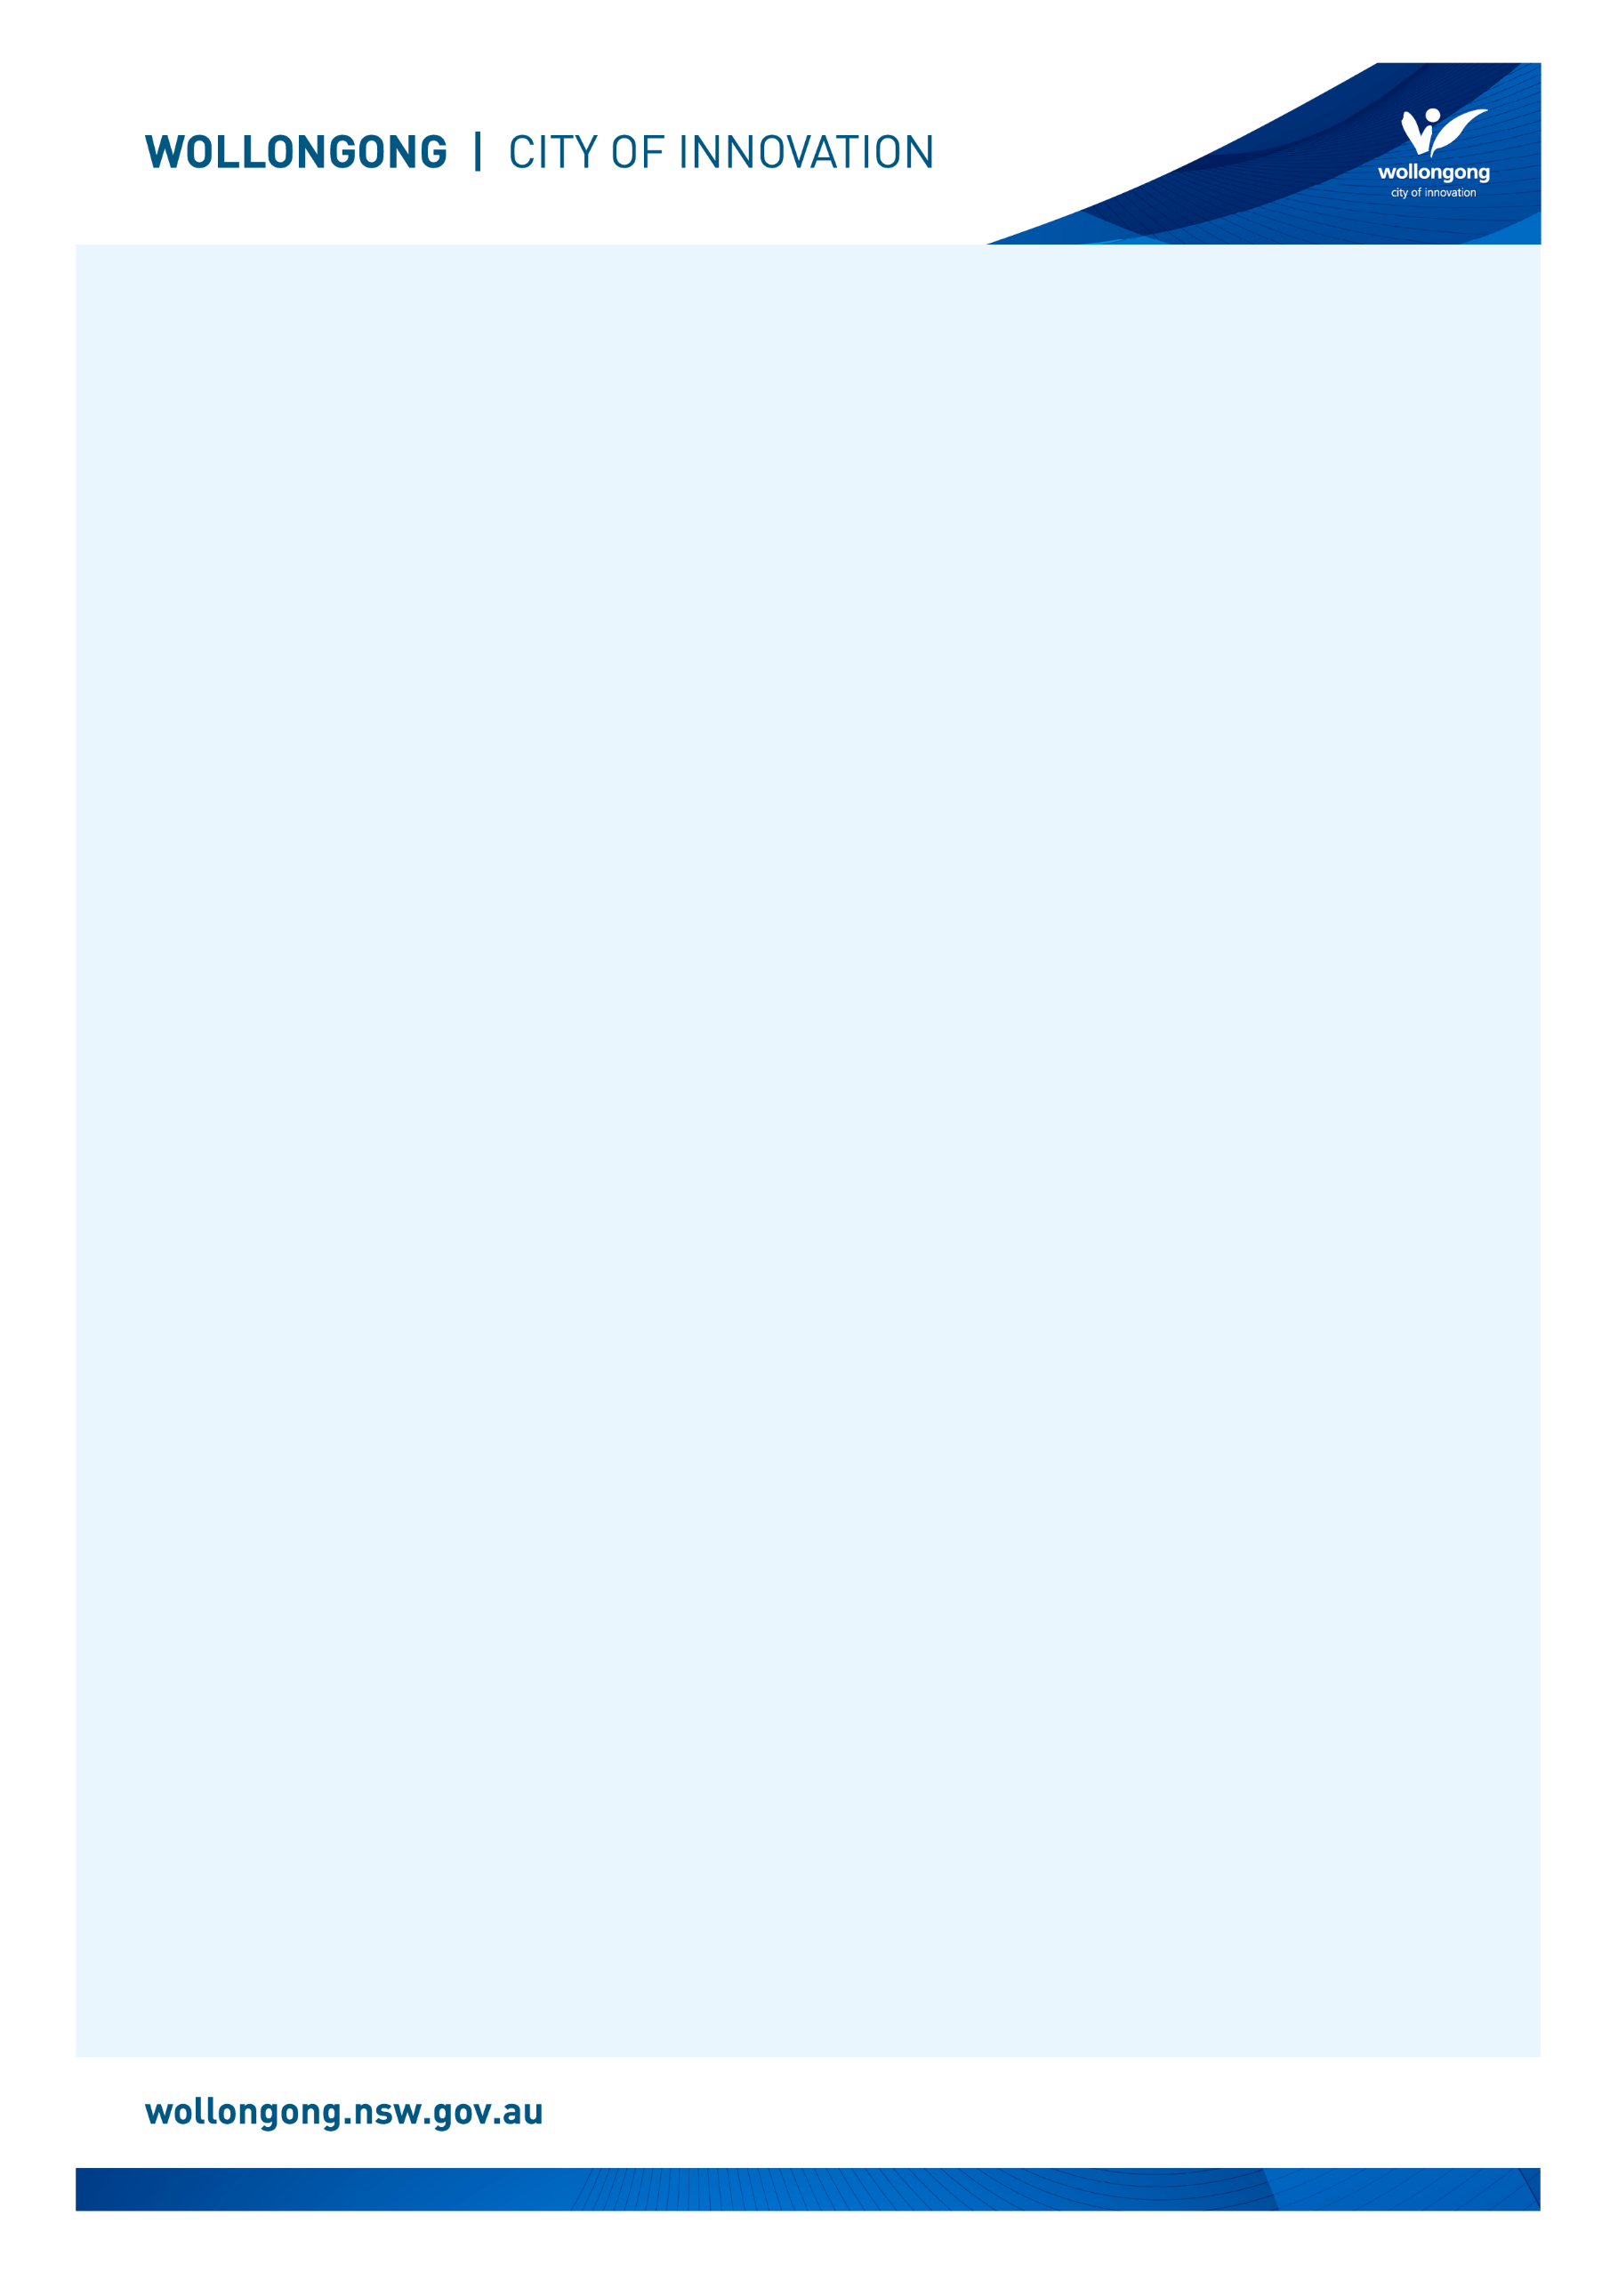

## Front facade of Helensburgh Library - a bitumen pathway leading up to a small building surrounded by grass and plants. Before I go to the library

# Going to

# Helensburgh Library

|  |  |
| --- | --- |
| I’m going to Helensburgh Library. | The front entry glass door at Helensburgh Library. |
| If I am nervous about going, I can talk to someone and ask questions first. I can phone Helensburgh Library on (02) 4227 2185. | A female library staff member talking on the phone at the library service desk. |

## About the library

|  |  |
| --- | --- |
| There are people who work at the library who I can talk to. | A staff member wearing a green jumper is putting books back on the shelf in the library. |
| The library is usually a quiet place where people talk quietly, relax and read books. | Three rows of bookshelves and a self-checker machine at Helensburgh Library. |
| Sometimes it might be loud. If it gets too noisy, I can ask the library staff for help. | Two librarians are singing at the front of a group of parents and children sitting on the floor inside the library. They are participating in a children's program. |

## How I become a member of the library

|  |  |
| --- | --- |
| When I get to the library I will see a desk. | A large computer on top of the library front desk. |
| I will talk to someone who works there to become a library member. | A female library staff member with long brown hair stands behind the Helensburgh Library desk and smiles into the camera. |
| I will tell them my name, address, date of birth, telephone number, and email address. | A teenage boy and girl are smiling as they stand at the library front desk talking to a female librarian with brown hair and glasses. |
| I will need to bring one form of identification with my name and address, such as a driver’s licence or concession card. | A graphic representation of a blue and white ID card. |
| I'll answer some questions and learn about borrowing. I will receive a library card, and this makes me a library member. | Four Wollongong City Libraries' library cards, in the colours gold, orange, blue and pink. |

## When I visit the library

|  |  |
| --- | --- |
| In the library there will be shelves of books, CDs, DVDs, and magazines. | A shelf full of colourful books in Helensburgh Library. |
| I can sit in a chair to read a book. | A woman sitting down at a small table next to a window in a grey upholstered chair. She is reading the newspaper at Helensburgh Library. |
| I can borrow a book, CD, DVD, or magazine and take it home with me for four weeks. | A man and woman looking at books on a library shelf. |
| If I want to borrow a book, CD, DVD, or magazine I will talk to a library staff member. | A young woman talks with a library staff member about a book they are holding. |
| The staff will show me how to borrow the book, CD, DVD, or magazine and tell me when I need to bring it back to the library. | A young girl borrows a book on the Corrimal Library self-checkout machine. |
| The library will also have some computers. | Two public computers next to a window at Helensburgh Library. |
| The computers are free to use with my library card. | A woman in a green jumper is sitting at a computer at Helensburgh Library typing on a keyboard. |
| One of the computers has a Vision Australia keyboard for people with low vision. | A public computer monitor with a mouse and a yellow and black Vision Australia keyboard. |
| The library has some sensory tools I can borrow when I am in the library. I can ask a library staff member to borrow sensory tools. | A pile of sensory tools including headphones, two tangle fidgets, liquid motion sand timer, a silicone pop ball and a plush turtle. |
| The library has a bathroom I can use. | A blue door to the bathroom at Helensburgh Library. There are bookshelves on either side of the door. |
| When I have finished,  I will leave the library through the main door. | View from inside the library of the front entry glass door at Helensburgh Library. |
| I’ll come back to my library to return the things I borrowed and find new things to take home! | A metal box with a silver handle at the top for customers to return their books. On the box, there are orange signs that say "Return your items here." and "Thank you." |
| I can use the return chute outside or inside my library to return what I borrowed. | A small metal square with a sign above it that says Return Chute - Helensburgh Library's internal returns chute. |

We look forward to seeing you at Helensburgh Library again soon!

[](https://www.google.com.au/url?sa=i&rct=j&q=&esrc=s&source=images&cd=&cad=rja&uact=8&ved=2ahUKEwivyODlzdzdAhUEXLwKHfQEA64QjRx6BAgBEAU&url=https://en.wikipedia.org/wiki/Moran's_I&psig=AOvVaw0mKyTROxNryIM0I3cnBMSp&ust=1538186603827848)

**FINISHED**