Neighbourhood Forum 5  Wollongong’s Heartland | 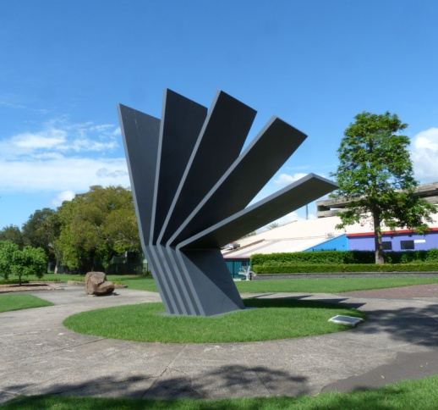 | Coniston, Figtree, Gwynneville, Keiraville, Mangerton, Mount Keira, Mount St Thomas, North Wollongong, West Wollongong, Wollongong City.

LATE BUSINESS for meeting at 7.00 pm Wed. 2nd October 2019

Presentation Unfortunately Catherine Geenty has advised that she is unable to make the meeting this week.

So it is proposed to have a discussion on the next steps to be taken on Medium Density Development in inappropriate locations. Last week the Minister of Planning made a number of important announcements which offer us a great opportunity to move forward. The secretary, who heard the Minister speak, will lead the discussion.

Wollongong Local Planning Panel
The community group opposed to the outrageous proposal for town houses in Murphys Avenue, Keiraville are incensed at the reports presented and the procedures at the Wollongong Local Planning Panel when it considered this. It turns out later that the Panel has refused the application but intimated a revised proposal with one less unit might be acceptable. This is a classic example of an ambit claim and then back-off to something way beyond the reasonable.

Recommendations
that Council be advised of serious concerns about:
1 the advice being proffered on DA's in relation to flooding, such that a moratorium on development in flood plains should be imposed until revised Studies have been completed;
2 the advice being proffered on DA's in relation to traffic and parking, specifically in relation to development west of Robsons Road;
3 the advice being proffered on DA's in relation on-site traffic movement, specifically turning circles;
4 the advice being proffered on DA's in relation to the assessment of local character, which flies in the face of any rational interpretation;
5 the protocols of the Wollongong Local Planning Panel in relation to community presentations;

and seek urgent meetings with the Director of Infrastructure + Works and with the acting Director of Planning + Environment to discuss the situation.

DA/2019/1008 eight storey building, 1 Smith St Wollongong
16th October
This is a proposal for 6 large units in an 8 storey building, over a 2 level basement car park, on the south-west corner of Smith and Harbour Streets. It has 5 complete floor apartments and a three level penthouse. It seems to comply with Council requirements, save a couple of minor issues which do not affect neighbours, and a Heritage Impact Statement has been provided. Residential development in the vicinity is almost exclusively in units, a number of similar scale to that proposed. Perhaps the most unsatisfactory aspect is the pokey, uninviting lift lobby, but with only 6 units this is probably not an issue.

Recommendation
That a submission of support be lodged.

DA/2019/980 Two units in a 4 storey Building, 82A Cliff Road Wollongong

It turns out that this is even worse than was reported in the business paper. Whilst the street frontage is 14.5m the actual site width is 13m and so well below the minimum for a dual occupancy and nearly half the width needed for the type of building proposed.

Worse still, Osborne Park is also a listed Heritage Conservation Area and the proposal would dominate it to an unacceptable degree.

Parking at Beaton Park
"I am pleased to inform you that a work order has been created for the line marking of the ninety degree angle parking within the subject overflow parking area. This line marking will be installed subject to available staff resourcing within the works division and contractor availability. Thank you for notifying us in relation to the parking of vehicles on the grassed area. The condition of this area will be monitored and measures to address poor parking behaviour investigated if unsatisfactory surface condition is identified.

In response to the concerns raised in relation to bus stops in the precinct, no changes are planned at the present time. There are bus stops on or adjacent to the site on Throsby Drive, Foley Street and Crawford Avenue. The bus stop on the western side of Foley Street is a short distance from the pedestrian refuge island adjacent to the driveway to Beaton Park. This facility provides a safe crossing point for users travelling between this bus stop and Beaton Park. For users travelling from Gipps Road, the traffic signals at the Foley Street intersection include marked foot crossings on the three road approaches.

For users travelling from the Crawford Avenue bus stop to Beaton Park via Gipps Street, the very low traffic volumes in Gipps Street east of Crawford Avenue make it fairly easy to cross Gipps Street at that location. Traffic signals at the intersection of Denison Street and Throsby Drive provide a safe crossing point for bus patrons travelling to/from the stop on the southern side of Throsby Drive."

Senior Traffic Engineer

