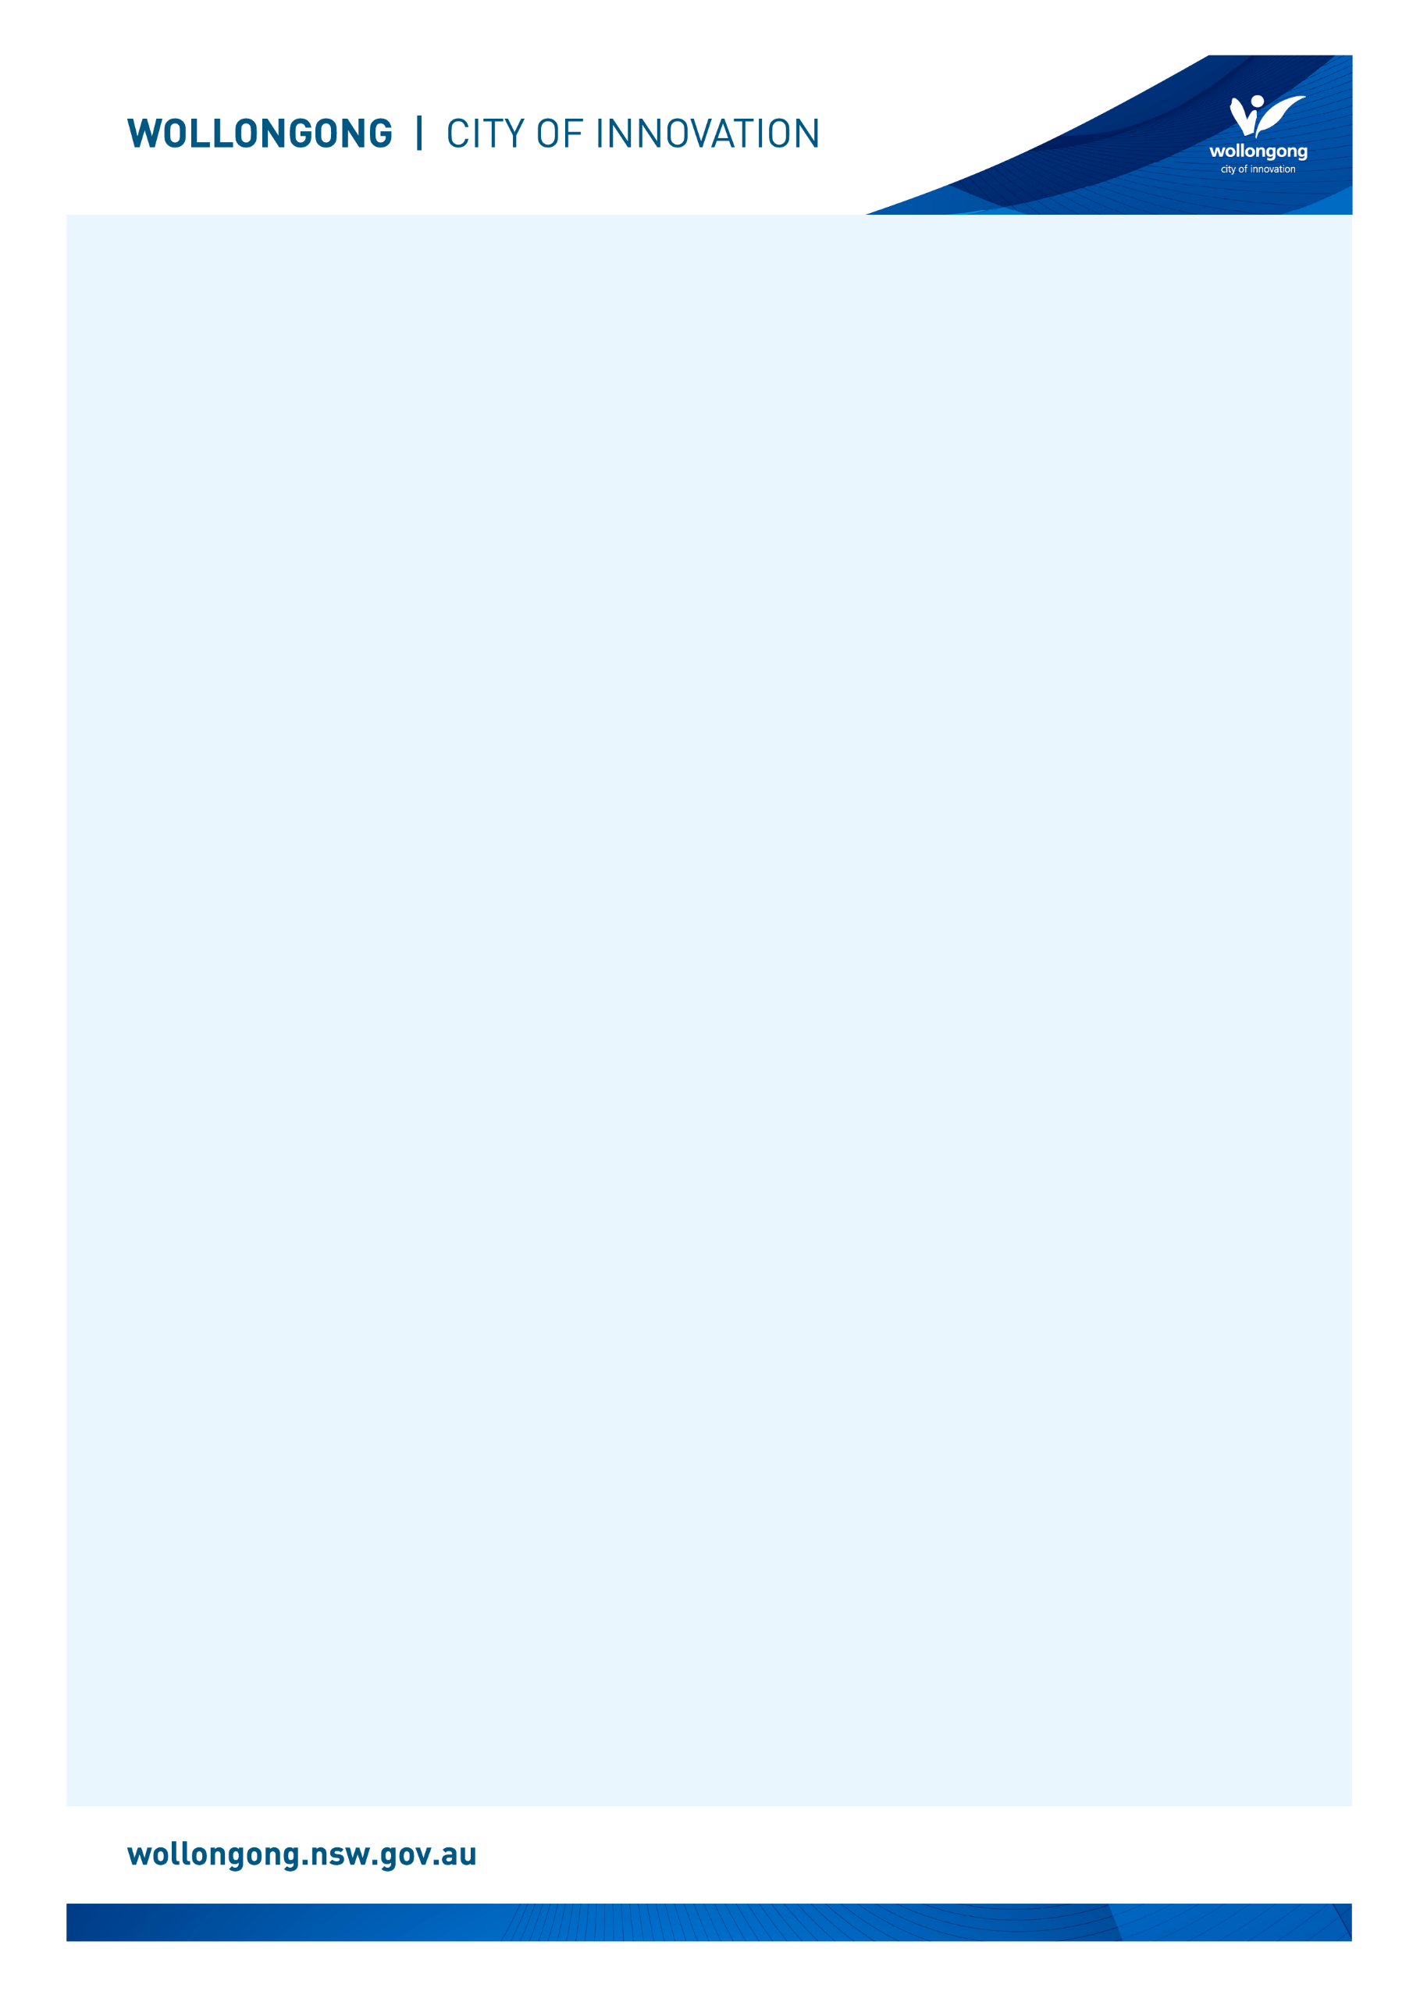

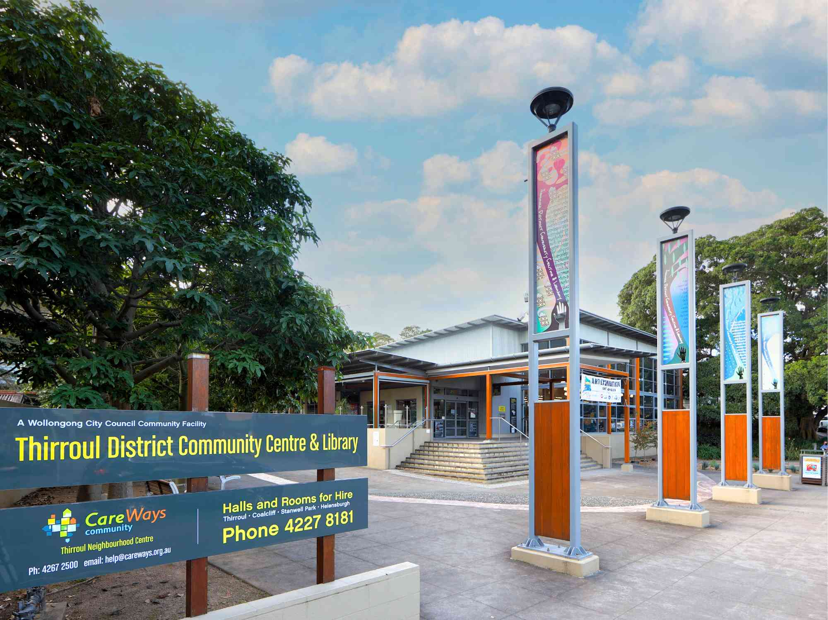

# Going to

# Thirroul Library

## Before I go to the library

|  |  |
| --- | --- |
| I’m going to Thirroul Library. | The front entry glass doors of Thirroul Library. |
| If I am nervous about going, I can talk to someone and ask questions first. I can phone Thirroul Library on (02) 4227 8191. | A librarian smiling behind the Thirroul Library front desk while talking on the phone. She is also standing at a computer. |

## About the library

|  |  |
| --- | --- |
| There are people who work at the library who I can talk to. | A female library staff member wearing white pants and a black shirt stands in between library shelves and places a book back on the top left shelf. |
| The library is usually a quiet place where people talk quietly, relax and read books. | A wide shot of Thirroul Library with customers sitting at desks studying. There are also sculptures of fish hanging from the ceiling. The space is filled with natural light coming from the floor to ceiling windows. |
| Sometimes it might be loud. If it gets too noisy, I can ask the library staff for help. | A librarian is reading a book in front of a crowded audience of parents and their young children. They are participating in a children's program. |

## How I become a member of the library

|  |  |
| --- | --- |
| When I get to the library I will see a desk. | The Thirroul Library front desk which is grey and curved with stripes of timber. |
| I will talk to someone who works there to become a library member. | A librarian is standing behind a computer at the Thirroul Library front desk and smiling while looking at the camera. |
| I will tell them my name, address, date of birth, telephone number, and email address. | Two women are sat opposite each other at a seated customer service counter at Thirroul Library. |
| I will need to bring one form of identification with my name and address, such as a driver’s licence or concession card. | A graphic representation of a blue and white ID card. |
| I'll answer some questions and learn about borrowing. I will receive a library card, and this makes me a library member. | Four Wollongong City Libraries' library cards, in the colours gold, orange, blue and pink. |

## When I visit the library

|  |  |
| --- | --- |
| In the library there will be shelves of books, CDs, DVDs, and magazines. | A young man wearing a hat is browsing the DVD collection at Thirroul Library. |
| I can sit in a chair to read a book. | A young woman with blonde hair is sat in a chair reading a book at Thirroul Library. There is a small circle table in front of her with three other chairs around it. |
| I can borrow a book, CD, DVD, or magazine and take it home with me for four weeks. | A woman in a yellow shirt is browsing the DVD's at Thirroul Library. |
| If I want to borrow a book, CD, DVD, or magazine I will talk to a library staff member. | A librarian is standing up next to a seated customer to help with something on the customer's computer. |
| The staff will show me how to borrow the book, CD, DVD, or magazine and tell me when I need to bring it back to the library. | A librarian is smiling while she is helping a man to use the self-checker machine at Thirroul Library. |
| The library will also have some computers. | A row of computers in front of the windows at Thirroul Library. |
| The computers are free to use with my library card. | A woman is sat at a public computer with one hand on the mouse and one hand on the keyboard. |
| One of the computers has a Vision Australia keyboard for people with low vision. | A public computer monitor with a mouse and a yellow and black Vision Australia keyboard. |
| The library has some sensory tools I can borrow when I am in the library. I can ask a library staff member to borrow sensory tools. | A pile of sensory tools including headphones, two tangle fidgets, liquid motion sand timer, a silicone pop ball and a plush turtle. |
| I can use the bathroom just outside the library in the community centre. | A long shot of the hallway in Thirroul Community Centre with public bathroom doors. |
| When I have finished, I will leave the library through the main door. | An internal view of Thirroul Library's glass sliding door entrance. |
| I’ll come back to my library to return the things I borrowed and find new things to take home! | A grey corrugated iron wall with a silver box on it and a yellow sign that says Library Returns. This is the Thirroul Library after hours returns chute. |
| I can use the return chute outside or inside my library to return what I borrowed. | A hole in the Thirroul Library front desk with a sign that says Returns above it. This is the Thirroul Library internal returns chute. |

We look forward to seeing you at Thirroul Library again soon!

[](https://www.google.com.au/url?sa=i&rct=j&q=&esrc=s&source=images&cd=&cad=rja&uact=8&ved=2ahUKEwivyODlzdzdAhUEXLwKHfQEA64QjRx6BAgBEAU&url=https://en.wikipedia.org/wiki/Moran's_I&psig=AOvVaw0mKyTROxNryIM0I3cnBMSp&ust=1538186603827848)

**FINISHED**