Neighbourhood Forum 5  Wollongong’s Heartland | 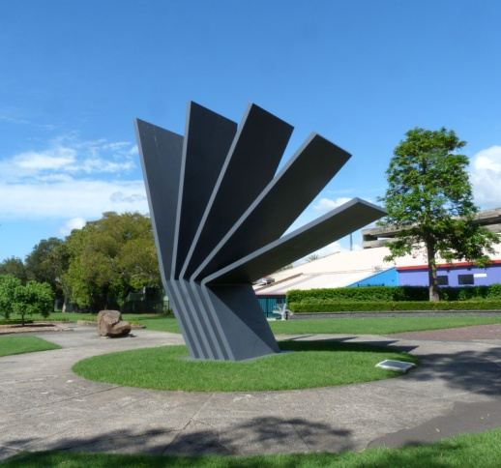 | Coniston, Figtree, Gwynneville, Keiraville, Mangerton, Mount Keira, Mount St Thomas, North Wollongong, West Wollongong, Wollongong City.

Minutes of meeting at 7.00 pm Wed. 1st May 2019 in the Town Hall Ocean Room

Present: the Lord Mayor and 28 members

1 Presentations Kerry Hunt, Chris Stewart, and Mike Dowd, were thanked for their presentation on WCC Delivery Program and Operational Plan, 2019 and for responding to questions.

2 Apologies were accepted

3 Minutes of meeting of 3rd April 2019 were adopted with no matters arising.

4 Comments from residents on the DA for townhouses, 58/60 Murphys Avenue Keiraville were noted - see p. 3 for the resolution.

5 Responses Crown Street Art Work: noted with regret.

Delivery Drones: noted

Crown Street Footpaths: noted with disbelief.

6 Reports WCC Delivery Program and Operational Plan, 2019
It was agreed that Council be advised that the Forum:
1 supports all the proposals which relate to their area, but as amended in 3 below;

2 seeks discussion/input into major Studies and Investigations and requests information on the timing of these:
i review of Fairy Cabbage Tree Creek Flood Study;
ii City Centre Planning Review - preferably through a Reference Group;
iii City Wide LEP Review - preferable in association with Neighbourhood Forum Alliance and the preparation of the Local Planning Strategy Statement;
iv Development of Crown Land Plans of Management;
v updated Landscape Master plan for Stuart and Galvin Parks, North Wollongong;
vi review of Inner City Parking Strategy;
vii the Integrated Transport Strategy;
viii Review of Wollongong City Centre Access and Movement Strategy 2013-23;
ix review of the Wollongong Bike Plan;
x development of an Integrated and Sustainable Transport Strategy;

3 comments, as noted in the attachment, with amendments and additions:
i remove reference to the mountain bike car park until such time as the Mountain Bike Strategy has been approved;
ii include as a matter of urgency the dredging of the Duck Pond at the Botanic Garden
iii include funding for an upgraded pedestrian crossing in Berkeley Road Gwynneville to safeguard children.

Roundabout on Gipps Road: noted

F6 Extension Stage 1
It was agreed that an objection be lodged to the latest Stage of the F6 Project and Ryan Park MP be supported in his endeavours on rail services.

Cycleway Signage Community Grant
It was agreed that the Forum support the grant application for such a grant.

Brian Reid
Condolences to the family were endorsed.

7 Activities Keiraville/Gwynneville Access Study:
It was agreed that our Ward Councillors be requested to intervene and demand that greater priority be given to this important community initiative than has been the case recently.

South Wollongong: noted

Neighbourhood Forums Alliance:
It was noted that there will be a meeting of the Alliance at 6pm on 13th May in the City Library to discuss the Local Planning Strategy in general and in particular the impact of medium density development in low density areas.

Bluescope Community Consultative Committee: noted

8 Planning DA/2019/286 Dual Occupancy, 2 Eastern St Gwynneville
It was agreed that the submission of support be endorsed subject to the rear setback of the dwelling on Lot 1 be complied with and/or windows eliminated.

DA/2019/292 Dual Occupancy, 28 Abercrombie St West W'gong
It was agreed that the submission of support be endorsed.

DA/2019/330 Gymnasium, 149 The Avenue, Figtree
It was agreed that the submission of support be endorsed.

DA/2019/284 10 townhouses, 58/60 Murphys Avenue Keiraville
It was agreed that a very strong submission of objection be lodged.

9 General/Late Public Spaces and Neighbourhood Parks
Business It was agreed that:
1 the submission to the Annual Plan on Land Use Planning request Council to include funding in 2019-20 for a review of the local open space needs, and the achievement of the Urban Greening Strategy, of the high density residential areas in and around the City Centre and that research information be attached;
2 the Ward Councillors be advised of our ongoing concerns, support the proposal and, if possible, for them attend the June Forum meeting to put their point of view.

Crown Street Markets
It was agreed to advise our Ward Councillors that we are receiving consistent and regular complaints from members about the plunging decline of the markets since the change in management, and request that they ensure that staff take steps to remedy the situation.

North Wollongong Station Parking
It was agreed to request State Rail to investigate opportunities and implement the provision of additional parking near the station.

Botanic Garden Master Plan
It was agreed to ask Council about the timing for completion of this important document.

10 Snippets noted

Next Meeting: 7.00 pm on Wed. 5th June 2019, Town Hall Ocean Room.

Current active membership of Neighbourhood Forum 5 : 392 households

