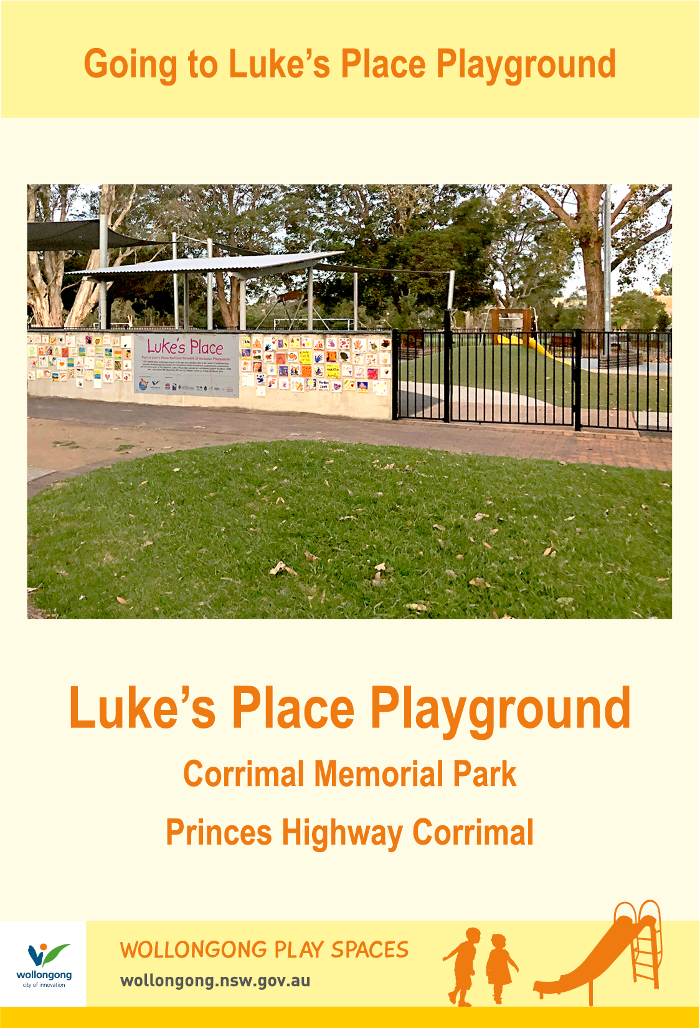

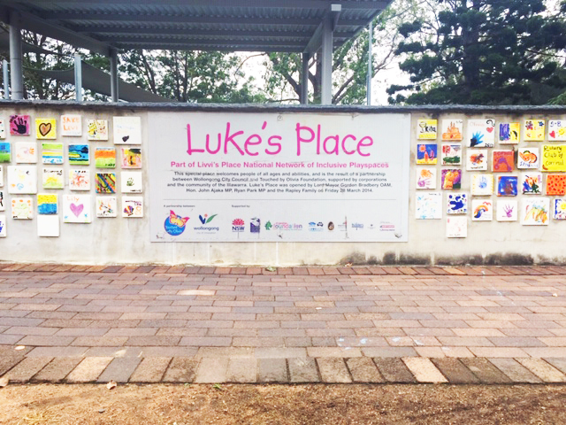

Today we are going to Luke’s Place Playground.

**Going to the Community Centre - Dapto**

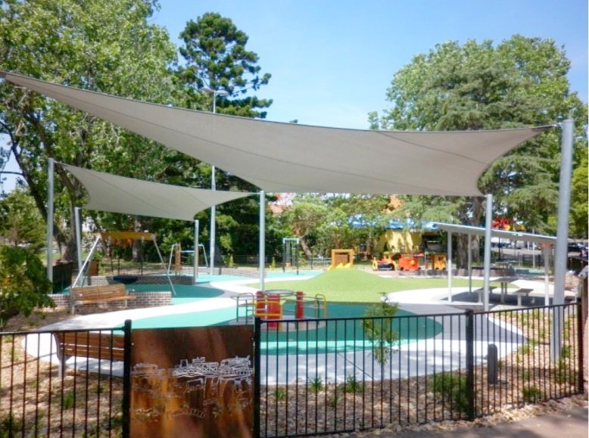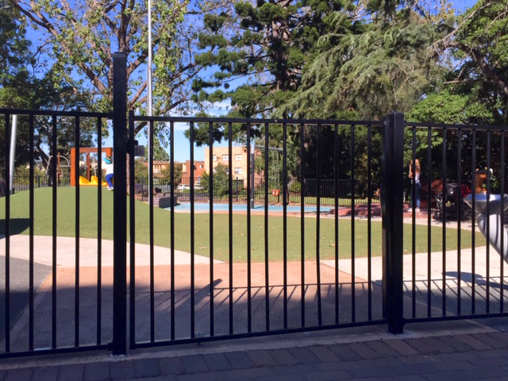

Luke’s Place has a fence to keep me safe.

I will let my parent or carer open the gate.

I can use the communication board to let people know what I would like to do while I am at Luke’s Place.

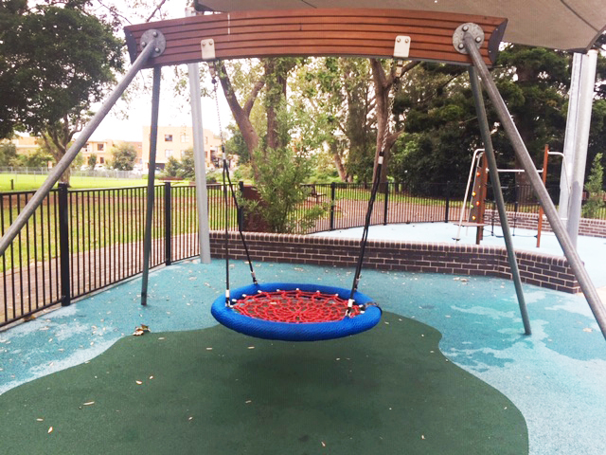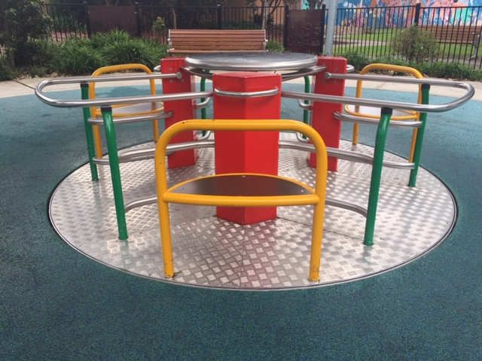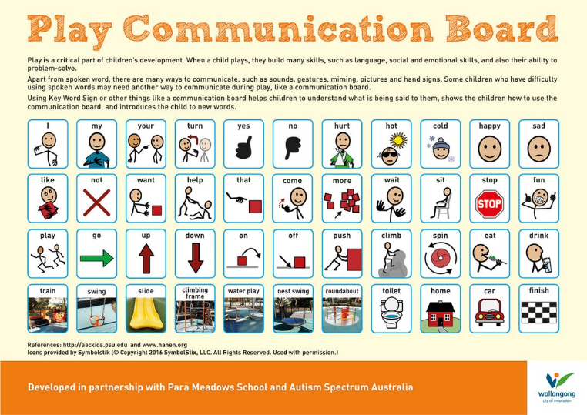

I can swing in the nest swing.

There are lots of fun things to do at Luke’s Place. I can play on the roundabout.

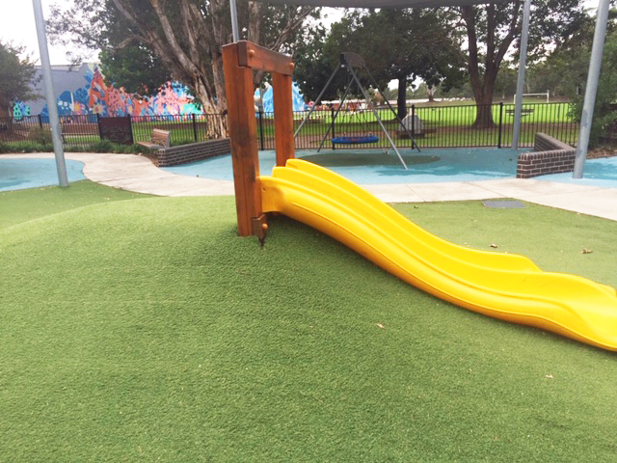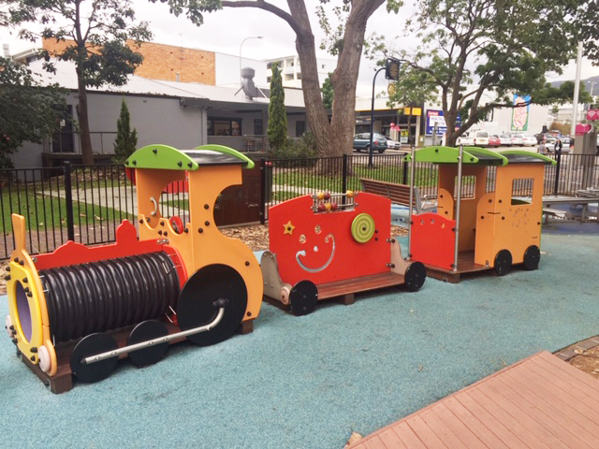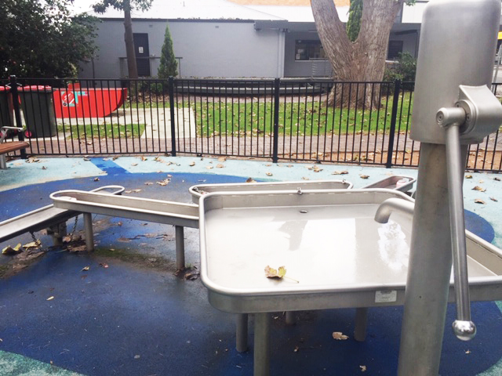

I can play with the train.

If it’s warm I can enjoy some water play.

I can have turns on the slide.

00

I can have a drink from the bubbler.

There is a table and chairs to have our lunch or a snack.

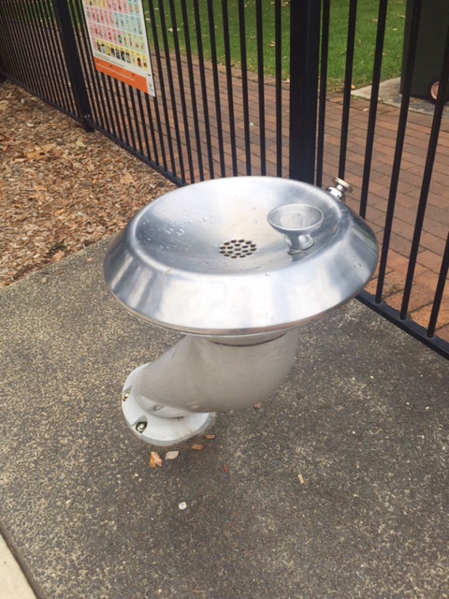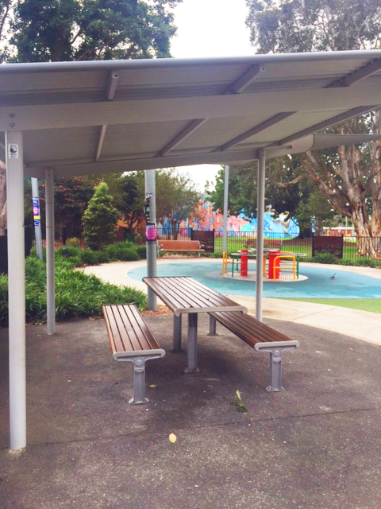

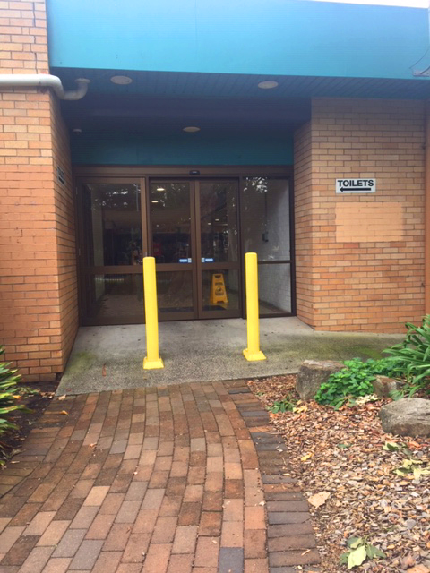[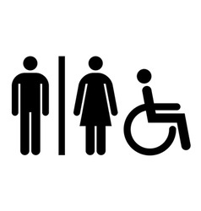](https://www.google.com.au/url?sa=i&rct=j&q=&esrc=s&source=images&cd=&cad=rja&uact=8&ved=2ahUKEwj0jJLX1KjfAhWLdH0KHdpUAyQQjRx6BAgBEAU&url=https://www.vectorstock.com/royalty-free-vectors/accessible-restroom-sign-vectors&psig=AOvVaw0XzAhO1nuSHng7z_GYDKHt&ust=1545197800010449)[](https://www.google.com.au/url?sa=i&rct=j&q=&esrc=s&source=images&cd=&cad=rja&uact=8&ved=2ahUKEwivyODlzdzdAhUEXLwKHfQEA64QjRx6BAgBEAU&url=https://en.wikipedia.org/wiki/Moran's_I&psig=AOvVaw0mKyTROxNryIM0I3cnBMSp&ust=1538186603827848)

We hope you had a great time at Luke’s Place Playground!

I can use the toilets next door in Corrimal Park Mall. There is a side entrance next to Luke’s Place.

**FINISHED**