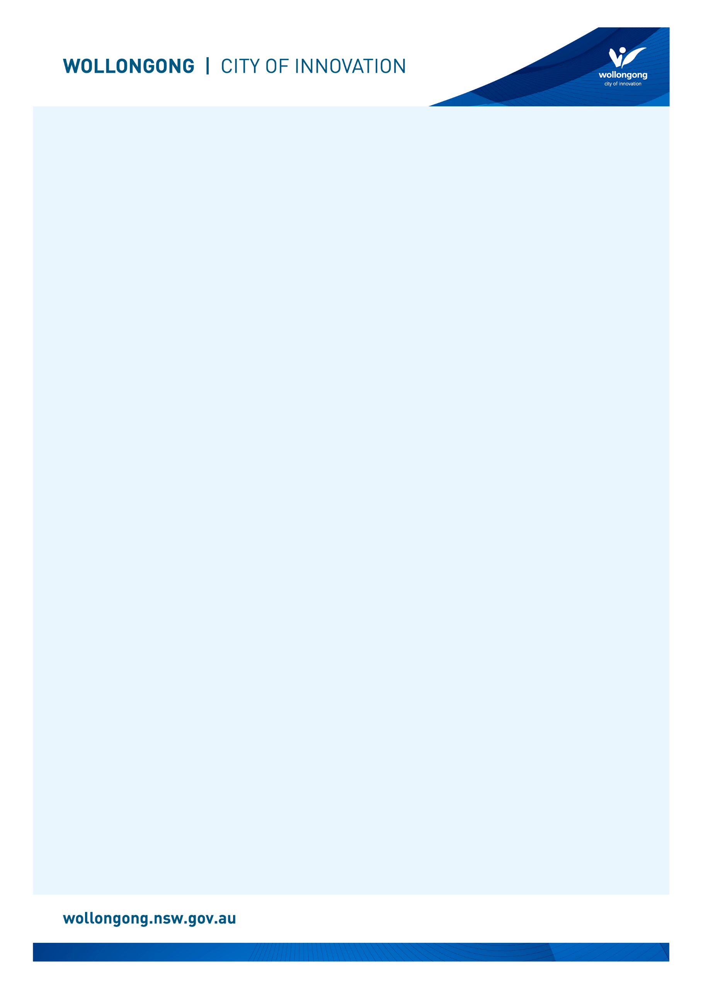

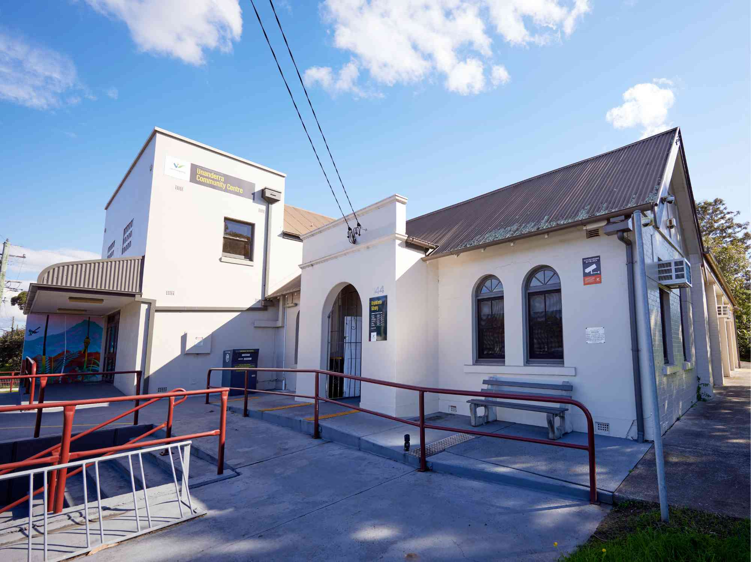

# Going to

# Unanderra Library

## Before I go to the library

|  |  |
| --- | --- |
| I’m going to Unanderra Library. | An archway to the front door of Unanderra Library. There is a sign next to the archway with the Unanderra Library opening hours. |
| If I am nervous about going, I can talk to someone and ask questions first. I can phone Unanderra Library on (02) 4227 8559. | A librarian with brown hair wearing a red shirt is smiling while talking on the phone. |

## About the library

|  |  |
| --- | --- |
| There are people who work at the library who I can talk to. | A librarian wearing glasses is smiling at the camera behind the Unanderra Library front desk. She has her hand on the mouse at the computer and is surrounded by books. |
| The library is usually a quiet place where people talk quietly, relax and read books. | A blue lounge chair beneath a window at Unanderra Library. |
| Sometimes it might be loud. If it gets too noisy, I can ask the library staff for help. | A group of women sitting on the floor with babies inside the library. They are participating in a children's program. |

## How I become a member of the library

|  |  |
| --- | --- |
| When I get to the library I will see a desk. | The Unanderra Library front desk has two computers on it. There are shelves behind the desk with books on them. |
| I will talk to someone who works there to become a library member. | A female customer with brown hair is at the desk where a librarian is standing at a computer to sign the customer up as a member. |
| I will tell them my name, address, date of birth, telephone number, and email address. | A female customer with brown hair is at the desk where a librarian is standing at a computer to sign the customer up as a member. The customer is holding up an orange library card in their hand. |
| I will need to bring one form of identification with my name and address, such as a driver’s licence or concession card. | A graphic representation of a blue and white ID card. |
| I'll answer some questions and learn about borrowing. I will receive a library card, and this makes me a library member. | Four Wollongong City Libraries' library cards, in the colours gold, orange, blue and pink. |

## When I visit the library

|  |  |
| --- | --- |
| In the library there will be shelves of books, CDs, DVDs, and magazines. | Shelves of books at Unanderra Library with a small round table and two blue upholstered chairs. |
| I can sit in a chair to read a book. | A woman with blonde hair is sitting on a chair reading a book. |
| I can borrow a book, CD, DVD, or magazine and take it home with me for four weeks. | A close up of a hand touching CD's on a shelf at Unanderra Library. |
| If I want to borrow a book, CD, DVD, or magazine I will talk to a library staff member. | Close up of a hand holding a pink library card in front of a self-checker machine. |
| The staff will show me how to borrow the book, CD, DVD, or magazine and tell me when I need to bring it back to the library. | Close up of a hand scanning the barcode of a library card on the self-checker machine. |
| The library will also have some computers. | Two public computers on a wooden desk at Unanderra Library. Each computer has a wooden chair in front of it. |
| The computers are free to use with my library card. | A customer with blonde hair is typing on the keyboard at a computer. |
| One of the computers has a Vision Australia keyboard for people with low vision. | A Vision Australia keyboard at a computer which has very large black text on yellow keys to help people with low vision. |
| The library has some sensory tools I can borrow when I am in the library. I can ask a library staff member to borrow sensory tools. | A pile of sensory tools including headphones, two tangle fidgets, liquid motion sand timer, a silicone pop ball and a plush turtle. |
| I can use the bathroom at the back of the library. | A white door opening into the bathroom at Unanderra Library. There is a bookshelf on either side of the door. |
| When I have finished, I will leave the library through the main door. I’ll come back to my library to return the things I borrowed and find new things to take home! | An internal view of the glass sliding doors at the front entrance to Unanderra Library. |
| I can use the return chute outside or inside my library to return what I borrowed. | The Unanderra Library external returns chute which is a large grey box with a handle at the top. There are also orange signs on the chute which say "Return your items here" and "Thanks for visiting your library." |

We look forward to seeing you at Unanderra Library again soon!

[](https://www.google.com.au/url?sa=i&rct=j&q=&esrc=s&source=images&cd=&cad=rja&uact=8&ved=2ahUKEwivyODlzdzdAhUEXLwKHfQEA64QjRx6BAgBEAU&url=https://en.wikipedia.org/wiki/Moran's_I&psig=AOvVaw0mKyTROxNryIM0I3cnBMSp&ust=1538186603827848)

**FINISHED**