Neighbourhood Forum 5  Wollongong’s Heartland | 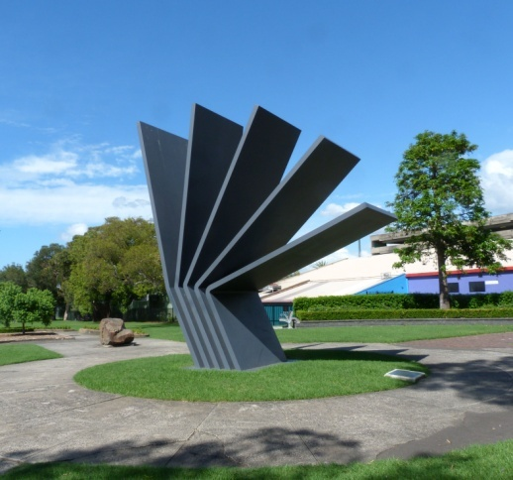 | Coniston, Figtree, Gwynneville, Keiraville, Mangerton, Mount Keira, Mount St Thomas, North Wollongong, West Wollongong, Wollongong City.

LATE BUSINESS for meeting at 7.00 pm Wed 11 Dec 2019 in the Town Hall

1 KeG Access Strategy (see Agenda item 7.1)
Council's prompt response to the request for clarification was:
"Councillors were given a briefing on 25 November on the Keiraville / Gwynneville Access and Movement Strategy. The briefing covered the background and key themes that have arisen through the investigations and community consultation, opportunities and actions to improve access, and the next steps.

The consultant’s report is currently being finalised and will be available for distribution to Councillors, NF5 and the University in early January (next month) before a formal exhibition is organised. As soon as we have the report we will be in contact and provide copies." Director Infrastructure + Works

Comment
Whilst the second paragraph is encouraging that the report will be distributed before formal exhibition, previously NF5 requested "a presentation and interactive discussion on the Strategy before it is presented to Council"

Recommendation
That a presentation and interactive discussion, together with the University, be sought on the Strategy, prior to exhibition.

2 DA2019/284, 58-60 Murphys Ave Keiraville - Amendments (see Agenda item 5.5)
"Please find attached the approved plans plus the officers supplementary report which addresses the amended plans and panel decision. Notwithstanding the ongoing objections to the proposal from nearby residents, it was not considered necessary to re-notify the amended plans. I hope that this report will assist NF5 and concerned residents in understanding the final outcome."
Manager Development Assessment and Certification
Recommendation
Further clarification be sought on why, when floor space on other units was increased to compensate for the removal of a unit, thus effectively having the same impact, re-notification was not considered necessary.

3 Council’s Climate Action recommendations (Council meeting item3, Dec 9th)
It is good to see Council moving forward on climate action. The proposed recommendations on "Emission Reduction Target" include:

- That Council work towards an aspirational greenhouse gas emissions reduction target of net zero emissions by 2030 for organisational operations and that this commitment be reviewed in five (5) years to enable consideration of progress towards the target.
- That Council develop a Climate Change Mitigation Action Plan in collaboration with key stakeholders to assist all sectors of the community achieve the emissions reduction target for the Wollongong local government area.

Recommendation
That Council be advised:
1 The above two recommendations need to be more transparent. Both processes need to report back to Council on an annual basis on implementation strategies and progress towards reaching the targets.
2 The development of a Climate Change Mitigation Plan in collaboration with the community is a vital step. The recommendation lacks detail and a timeframe. Council needs to go through a public process to identify stakeholders and develop programs in the report back.
Felix Bronneberg

4 Agenda
" I have reviewed the agenda prior to placing on the Council website and note that the 10 snippet section of the agenda is not in line with the charter. It would be greatly appreciated if you could submit a revised version with this section removed. If a revised version is not received we will remove the section before posting."
Engagement Coordinator (Acting)
Comment
We have no idea what has apparently offended Council's Charter, we certainly had no intension to do so, and have advised Council to delete whatever they require before posting the NF 5 agenda on their website.

5 DA 2019/1288 521 Philip Avenue ( see Agenda item 8.8)
This proposal has been reviewed. It does not comply with our Locality Plan for Fairy Creek which would probably call for 11 rather than 14 dwellings. However, there are a large number of medium density dwellings nearby.

Recommendation
That no submission be made.

6 DA 2019/1290 16 Belmore St ( see Agenda item 8.9)
This proposal has been reviewed and it is agreed that the variations to standards are acceptable.

Recommendation
That the proposal be supported.

