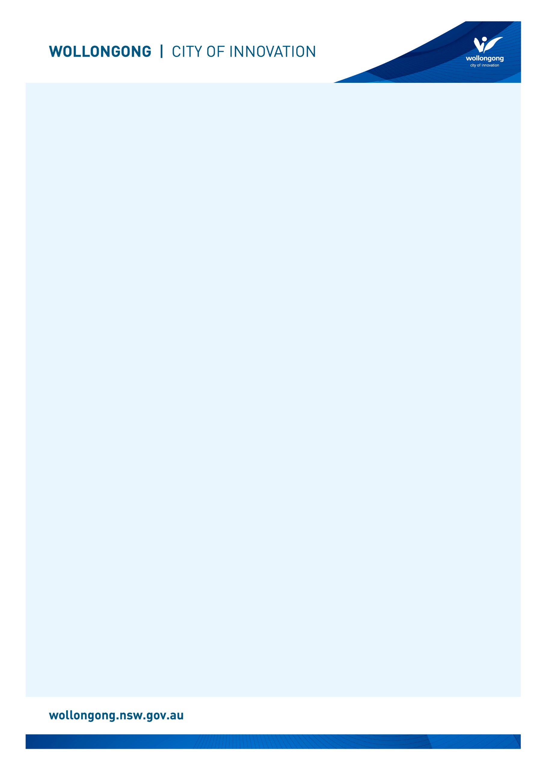

Front facade of Wollongong City Council and Library - a large white building with red brick paving out the front. There are also five tall poles with national flags raised. 

an orange brick building with a brick pathway and plants. A middle-aged couple is seated out the front, while a blonde woman walks out of the front door.

# Going to

# Wollongong Library

## Before I go to the library

|  |  |
| --- | --- |
| I’m going to Wollongong Library. | The front entry glass doors of Wollongong Library. |
| If I am nervous about going, I can talk to someone and ask questions first. I can phone Wollongong Library on (02) 4227 7414. | A female library staff member with brown hair talking on the phone at the library service desk. |

## About the library

|  |  |
| --- | --- |
| There are people who work at the library who I can talk to. | A staff member with short hair and thick black glasses is smiling while putting books back on the shelf in the library. |
| The library is usually a quiet place where people talk quietly, relax and read books. | A wide shot of Level 1 at Wollongong Library including wooden tables with red and white chairs where people are working and studying. |
| Sometimes it might be loud. If it gets too noisy, I can ask the library staff for help. | A librarian is sat on a colourful chair in front of a large group of parents and their young children. They are participating in a children's program. |

## How I become a member of the library

|  |  |
| --- | --- |
| When I get to the library I will see a desk. | A large curved desk with two computers that says HELP DESK in big white letters on it. |
| I will talk to someone who works there to become a library member. | Two librarians standing together and smiling at the camera behind the Wollongong Library help desk. |
| I will tell them my name, address, date of birth, telephone number, and email address. | A librarian sitting down behind a computer at the Wollongong Library front desk and smiling at the camera. |
| I will need to bring one form of identification with my name and address, such as a driver’s licence or concession card. | A graphic representation of a blue and white ID card. |
| I'll answer some questions and learn about borrowing. I will receive a library card, and this makes me a library member. | Four Wollongong City Libraries' library cards, in the colours gold, orange, blue and pink. |

## When I visit the library

|  |  |
| --- | --- |
| In the library there will be shelves of books, CDs, DVDs, and magazines. | A shelf full of books in front of a green wall at Wollongong Library. |
| I can sit in a chair to read a book. | A young woman sat in a red chair smiling with a book sat open on her lap. |
| I can borrow a book, CD, DVD, or magazine and take it home with me for four weeks. | A cream coloured shelf full of DVDs at Wollongong Library. |
| If I want to borrow a book, CD, DVD, or magazine I will talk to a library staff member. | A librarian with short hair and thick black glasses smiling at the camera and holding children's picture books. |
| The staff will show me how to borrow the book, CD, DVD, or magazine and tell me when I need to bring it back to the library. | A young woman tapping the screen on a self-checker machine at Wollongong library. |
| The library will also have some computers. | A row of public computers in Wollongong Library. |
| The computers are free to use with my library card. | A woman sitting at a public computer desk in Wollongong Library. |
| One of the computers has a Vision Australia keyboard for people with low vision. | A public computer monitor with a mouse and a yellow and black Vision Australia keyboard. |
| The library has some sensory tools I can borrow when I am in the library. I can ask a library staff member to borrow sensory tools. | A pile of sensory tools including headphones, two tangle fidgets, liquid motion sand timer, a silicone pop ball and a plush turtle. |
| I can use the bathroom just outside the library in the foyer. | The door to the bathrooms next to the elevators in the foyer of the Wollongong City Council and Library building. |
| When I have finished, I will leave the library through the main door. | An internal view of the glass doors at the front entrance to Wollongong Library. |
| I’ll come back to my library to return the things I borrowed and find new things to take home! | A window which has a silver box with a handle on it and two blue arrows on either side. The is the external returns chute at Wollongong Library. |
| I can use the return chute outside or inside my library to return what I borrowed. | A window about a metal shelf - Wollongong Library's internal returns chute. |

We look forward to seeing you at Wollongong Library again soon!

[](https://www.google.com.au/url?sa=i&rct=j&q=&esrc=s&source=images&cd=&cad=rja&uact=8&ved=2ahUKEwivyODlzdzdAhUEXLwKHfQEA64QjRx6BAgBEAU&url=https://en.wikipedia.org/wiki/Moran's_I&psig=AOvVaw0mKyTROxNryIM0I3cnBMSp&ust=1538186603827848)

**FINISHED**