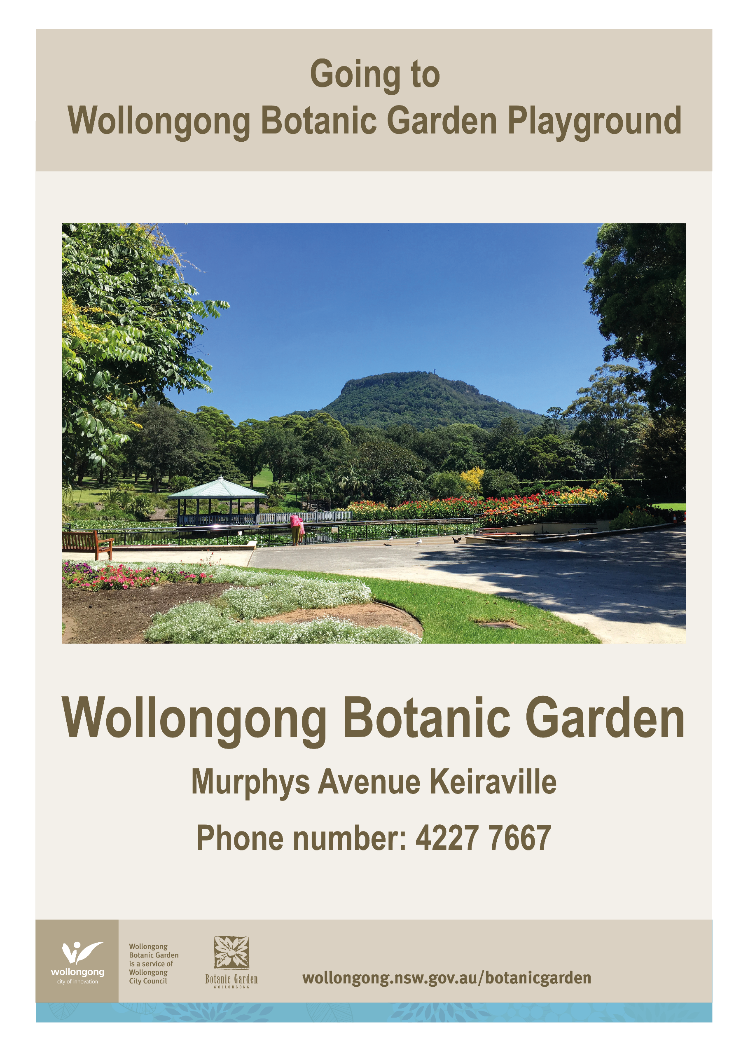

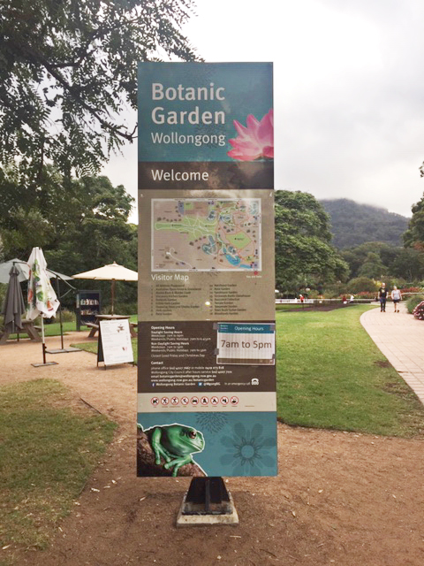

Today we are going to the Botanic Garden Playground.

**Going to the Community Centre - Dapto**

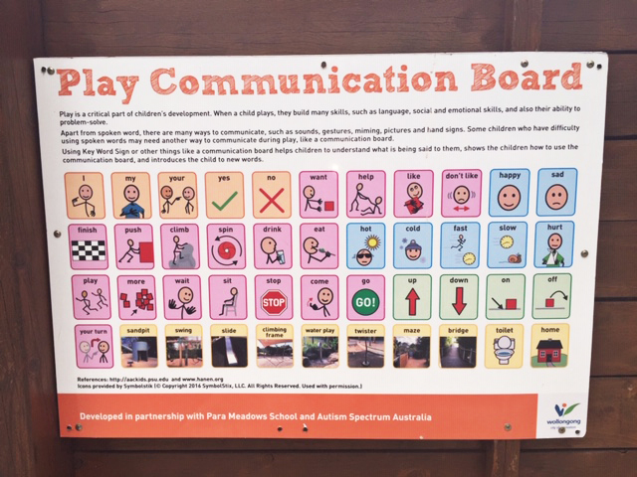

I can use the communication board to let people know what I would like to do while I am at the Botanic Garden Playground.

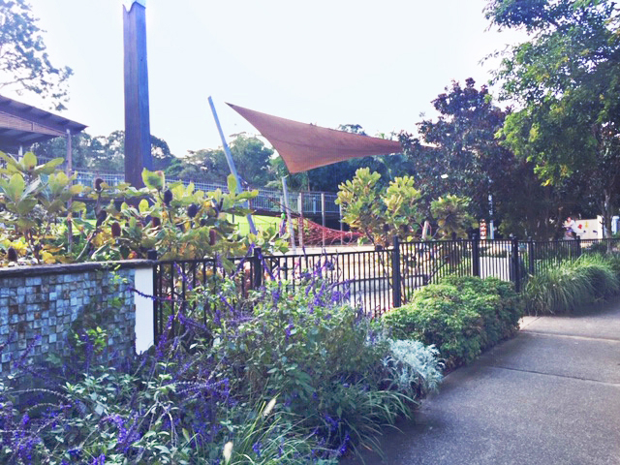

There is a fence to keep me safe.

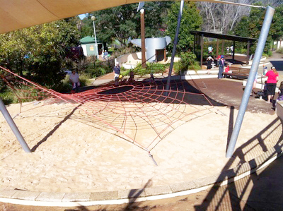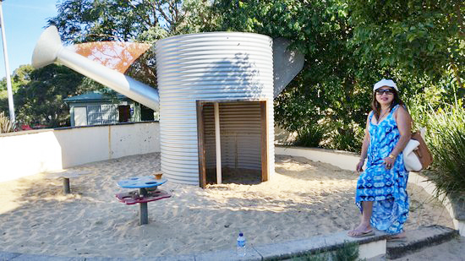

I can play in the sand or climb on the web.

There are lots of fun things to do at the Botanic Garden Playground.

I can play in the cubby.

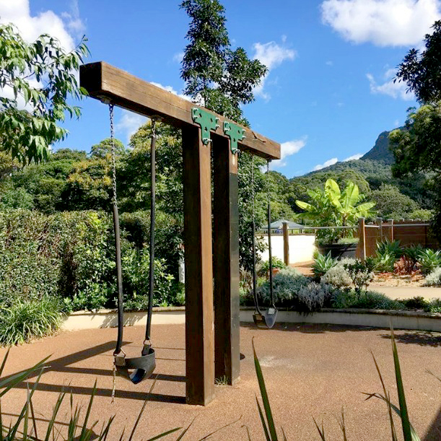

I can swing.

I can walk through the maze.

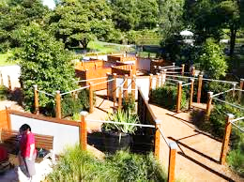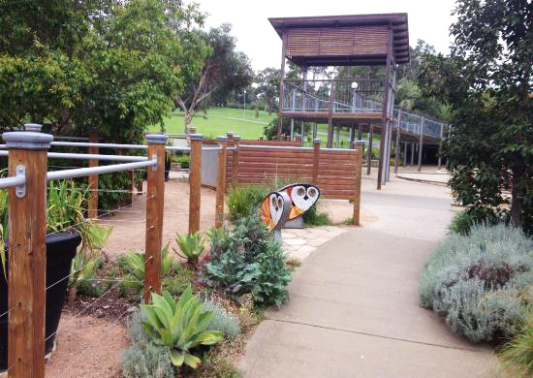

I can walk to the top of the viewing platform.

I can enjoy the view from up high.

I can use the toilets next to the Murphy’s Street entrance.

I can slide.

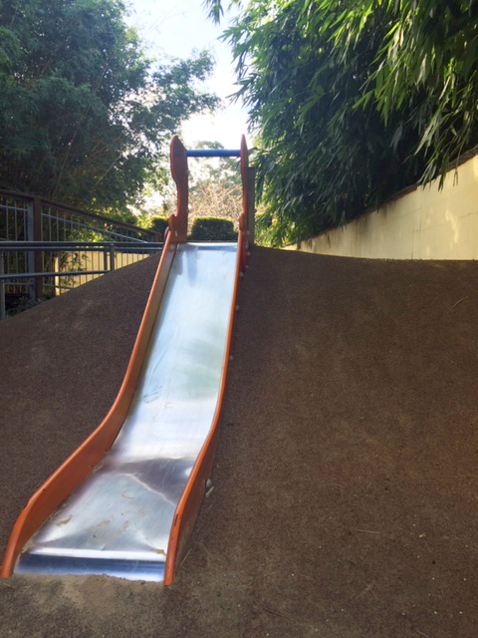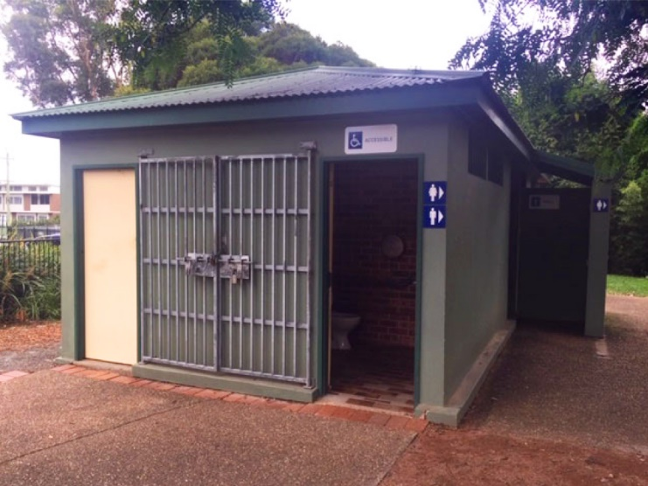[](https://www.google.com.au/url?sa=i&rct=j&q=&esrc=s&source=images&cd=&cad=rja&uact=8&ved=2ahUKEwj0jJLX1KjfAhWLdH0KHdpUAyQQjRx6BAgBEAU&url=https://www.vectorstock.com/royalty-free-vectors/accessible-restroom-sign-vectors&psig=AOvVaw0XzAhO1nuSHng7z_GYDKHt&ust=1545197800010449)

[](https://www.google.com.au/url?sa=i&rct=j&q=&esrc=s&source=images&cd=&cad=rja&uact=8&ved=2ahUKEwivyODlzdzdAhUEXLwKHfQEA64QjRx6BAgBEAU&url=https://en.wikipedia.org/wiki/Moran's_I&psig=AOvVaw0mKyTROxNryIM0I3cnBMSp&ust=1538186603827848)

We hope you had a great time at the Botanic Garden Playground!

**FINISHED**